Course _____12 Methods_____ Year __12___

Student name: ________________ Teacher name: ________________

Task type: Response/Investigation

Time allowed for this task: ____40_______ mins

Number of questions: _____7______

Materials required: No calculators nor classpads

Standard items: Pens (blue/black preferred), pencils (including coloured), sharpener, correction fluid/tape, eraser, ruler, highlighters

Special items: Drawing instruments, templates, notes on one unfolded sheet of
A4 paper, and up to three calculators approved for use in the WACE examinations

Marks available: ___40___ marks

Task weighting: _10___%

Formula sheet provided: Yes

Note: All part questions worth more than 2 marks require working to obtain full marks.

Q1 (2, 3 & 3 = 8 marks) (3.1.7-3.1.8)
Determine for each of the following.(No need to simplify)

Solution
Specific behaviours
correct coefficient
correct power (no need for positive power)

Solution
Specific behaviours
uses product rule
one correct product
two correct products (no need to simplify)

Solution
Specific behaviours
uses quotient rule
correct denominator
correct numerator(no need to simplify)

Q2 (2 & 3 = 5 marks) (3.1.8)
Consider .
- Determine

Solution
Specific behaviours
uses chain rule
evaluates derivative

- Determine the equation of the tangent at

Solution
Specific behaviours
solves for y value at x=0
solves for constant
states tangent equation

Q3 (1, 1, 3 & 3 = 8 marks) (3.1.7-3.1.8, 3.1.15)
Consider the following functions .
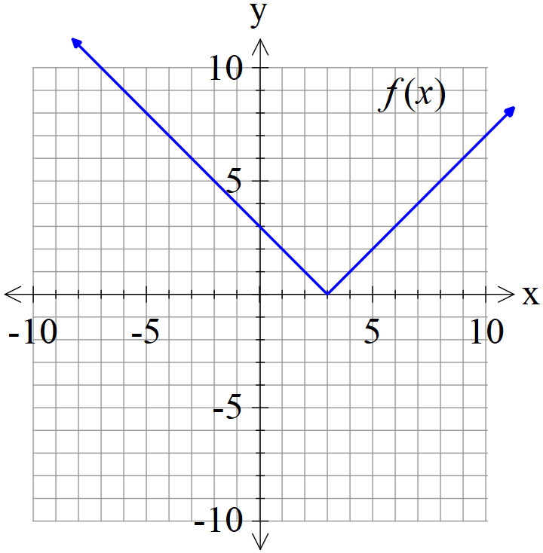 | 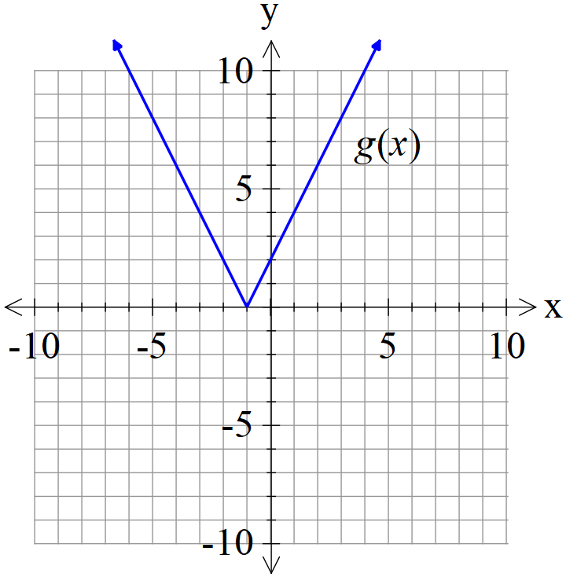

- Determine the derivative of when

Solution
Gradient = -1

Specific behaviours
states gradient

- Determine the derivative of when

Solution
Gradient = 6

Specific behaviours
states gradient

- Determine the derivative of when .

Solution
Specific behaviours
uses product rule
uses correct values for all variables
states final value

- Determine the derivative of when .

Solution
Specific behaviours
uses chain rule and is demonstrated
uses correct value for derivative of f
states final value
Q4 (2, 3 & 2 = 7marks) (3.1.13 – 3.1.17)
The following is the graph of , the derivative of .
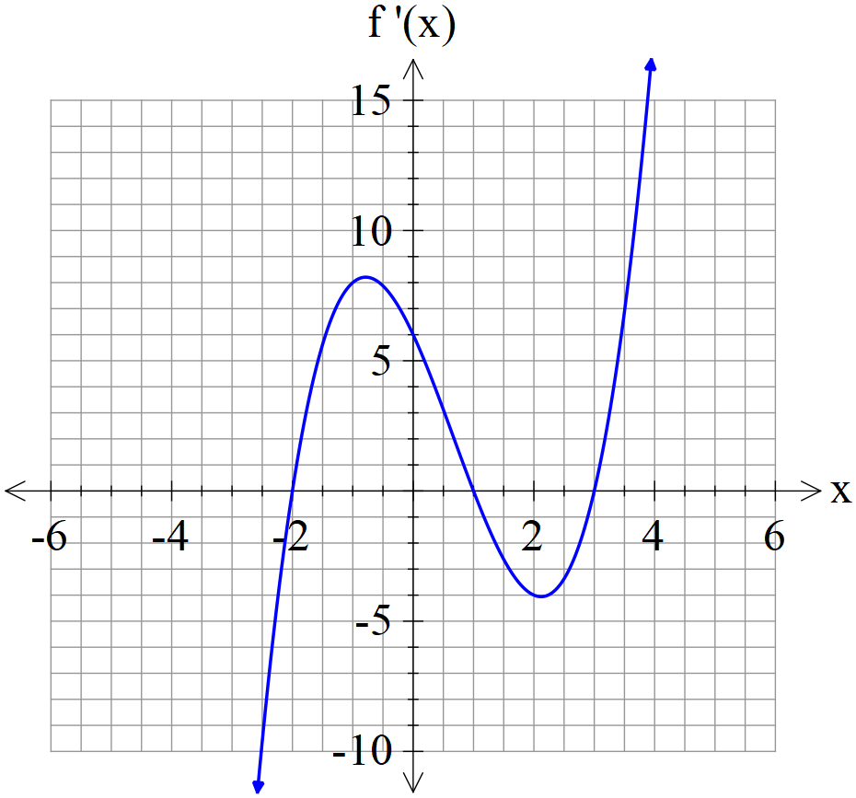
- State the x values of all stationary points of .

Solution
-2, 1 & 3

Specific behaviours
states one correct x value
states all three values

- State the nature of each stationary point above and justify.

Solution
-2, local min as
1, local max as
3, local min as
Specific behaviours
states nature of at least two stationary points
states reason using first or second derivatives for at least two pts
states nature and reason for all three stationary points

- State approximate x value for an infection point(s) and explain why.

Solution
Near -1 & 2 as

Specific behaviours
states near x values
states reason using second derivative
Q5 (3 & 2 = 5 marks) (3.1.12)
The displacement of a body from the origin O, at time seconds, is metres where

- Determine the time(s) that the velocity is zero metres/second.

Solution
Specific behaviours
differentiates
equates velocity to zero and factorises/quadratic formula
states both t values

- Determine when the acceleration is zero.

Solution
Specific behaviours
differentiates velocity
solves for t value

Q6 (3 marks) (3.1.10)
The period of a swinging pendulum of length is given by .
Using the increments formula, determine the approximate percentage change in if changes by 3%

Solution
Specific behaviours
uses increments formula
obtains expression for approx. change in T
obtains % change

.Q7 (4 marks) (3.1.16)
Consider a cylindrical container that has an open end. The surface area of the container is . Determine the exact value of the radius of the closed end that maximises the volume. (Justify)

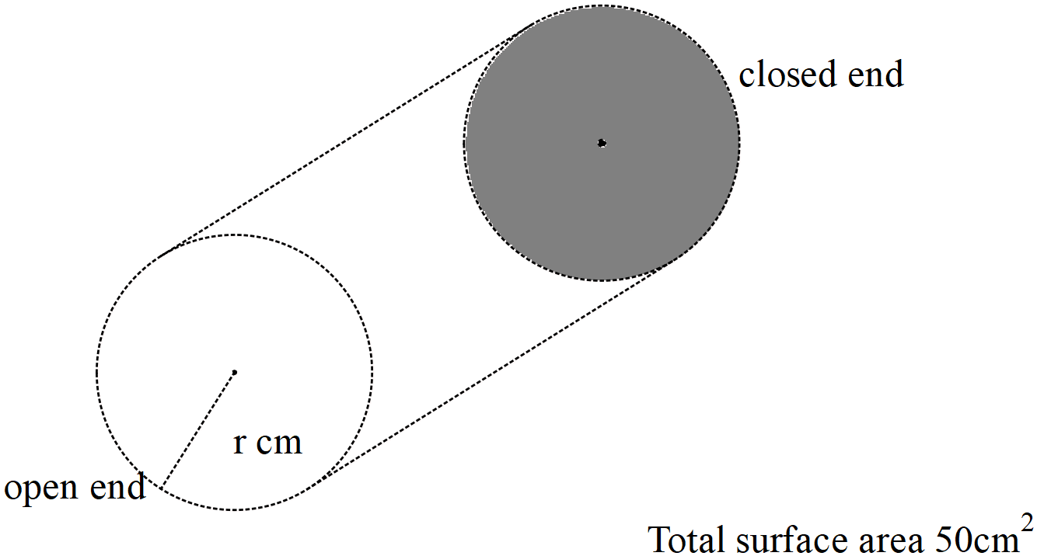

Solution
Specific behaviours
obtains constraint equation containing h & r
obtains expression for V in terms of one variable only
obtains derivative and equates to zero
obtains optimal value and confirms with second derivative

